Jawad Ahmad Khan  
22I-0791

**Q1**

|  |  |  |  |  |  |
| --- | --- | --- | --- | --- | --- |
|  | **CY** | **ZR** | **PE** | **OV** | **PL** |
| **Initial** | **0** | **1** | **1** | **0** | **0** |
| **After Addition** | **0** | **0** | **1** | **0** | **0** |
| **After Subtraction** | **1** | **0** | **0** | **0** | **1** |
| **After multiplication** | **0** | **0** | **0** | **0** | **1** |
| **After Division** | **0** | **0** | **0** | **0** | **1** |

**Comparing all with initial**

**After Addition:** The value is not becoming zero after adding the 2 numbers. ZR becomes 1. Parity is still odd so, PL remains 0, PE is 1 because value previously in ah can be anything and isn’t dependent on addition

**After Subtraction:** 1 is being taken as carry. So CY becomes 1. Value is not 0, so CY becomes 0 Party becomes even, so PL becomes 1. PE becomes 0, as the number is positive

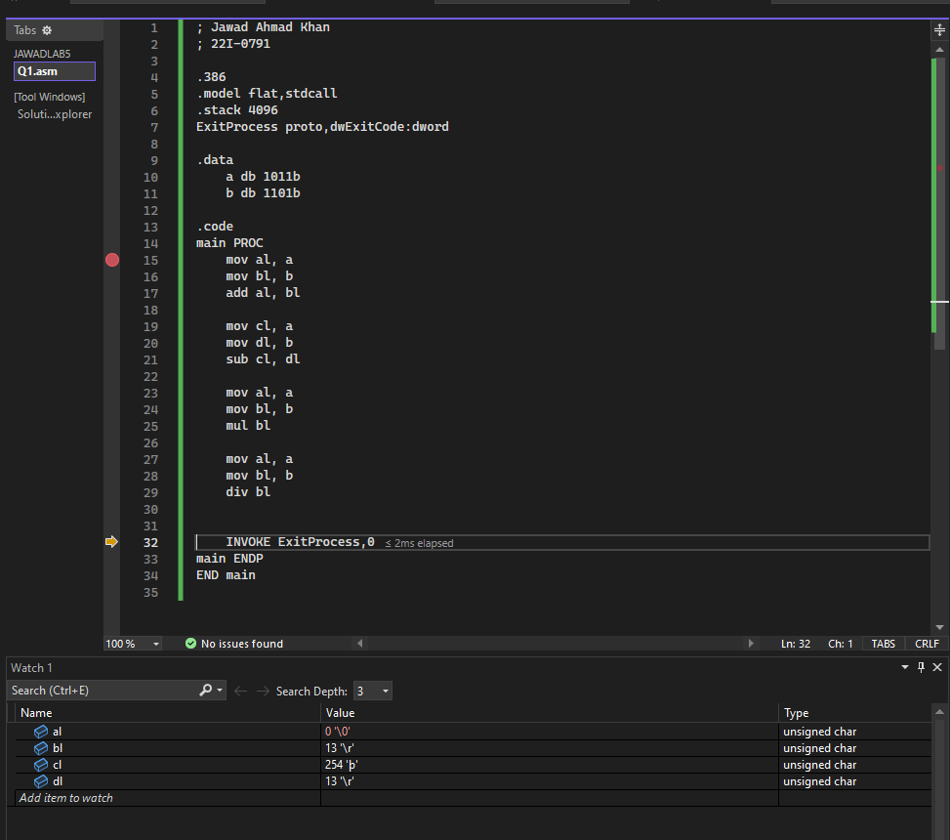

**Q2**

|  |  |  |  |  |  |
| --- | --- | --- | --- | --- | --- |
|  | **CY** | **ZR** | **PE** | **OV** | **PL** |
| **Initial** | **0** | **1** | **1** | **0** | **0** |
| **After Multiplication** | **0** | **0** | **0** | **0** | **0** |
| **After Decrement** | **0** | **0** | **0** | **0** | **0** |
| **After Addition** | **0** | **0** | **0** | **0** | **0** |
| **After Subtraction** | **0** | **0** | **1** | **0** | **0** |
| **After Increment** | **0** | **0** | **1** | **0** | **0** |

**Comparing all with initial**

**After Decrement:** Value is not 0, so ZR becomes 0. As we are reducing -1, then Parity becomes reverse, so 1 becomes 0

**After Addition:** Value is not 0, so ZR becomes 0. Parity is odd, so PE becomes 0

**After Subtraction:** Parity remains same, so PE remains 1

**After Increment:** Parity reverse as number is added by 1

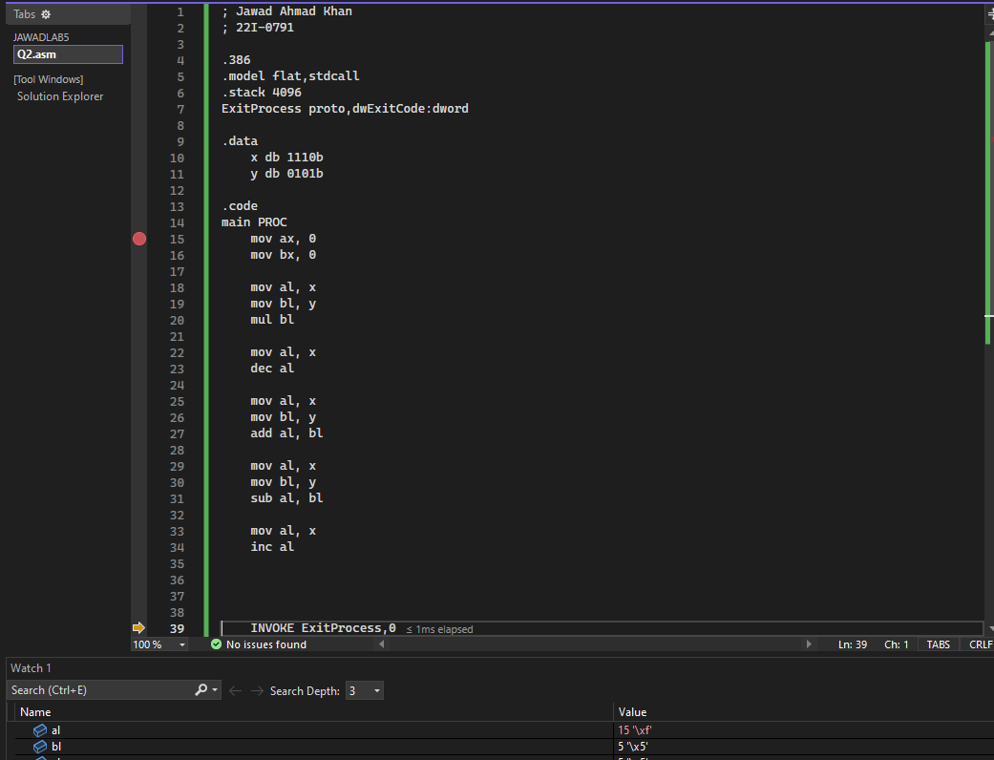

**Q3**

|  |  |  |  |  |  |
| --- | --- | --- | --- | --- | --- |
|  | **CY** | **ZR** | **PE** | **OV** | **PL** |
| **Initial** | **0** | **1** | **1** | **0** | **0** |
| **After Division** | **0** | **1** | **1** | **0** | **0** |
| **After Increment** | **0** | **0** | **1** | **0** | **0** |
| **After Decrement** | **0** | **0** | **0** | **0** | **0** |
| **After Addition** | **0** | **0** | **0** | **0** | **0** |
| **After Subtraction** | **1** | **0** | **1** | **0** | **1** |

**Comparing all with initial**

**After Increment:** Value is not 0, so ZR becomes 0.

**After Decrement:** Value is not 0, so ZR becomes 0. Parity is odd, so PE becomes 0

**After Addition:** Parity is odd, so PE is 0. Number is not 0, so ZR is 0

**After Subtraction:** We are taking a carry is smaller number is subtracted by larger. Parity is even, so PE becomes 1. Final answer is negative so PL is 1

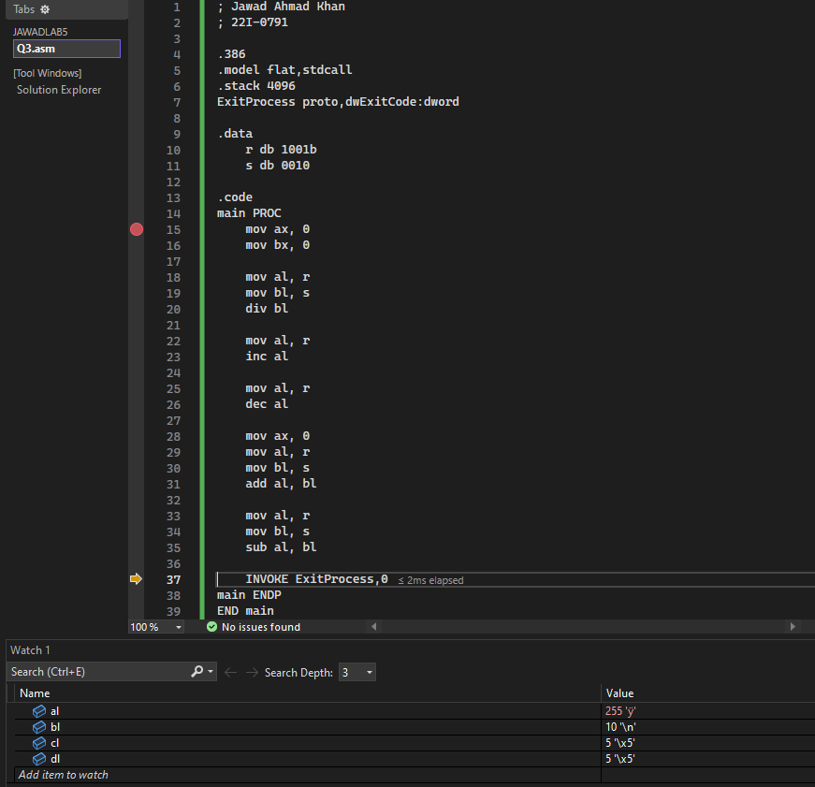

**Q4**

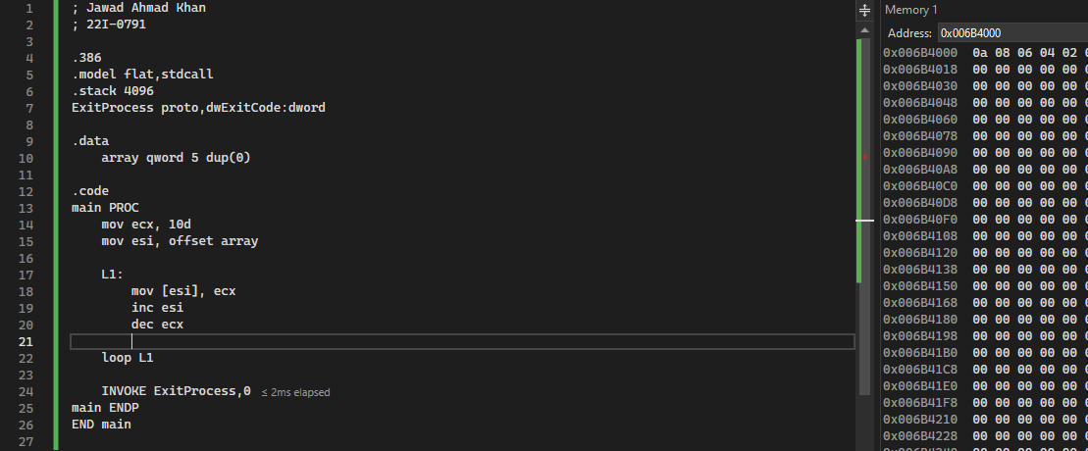

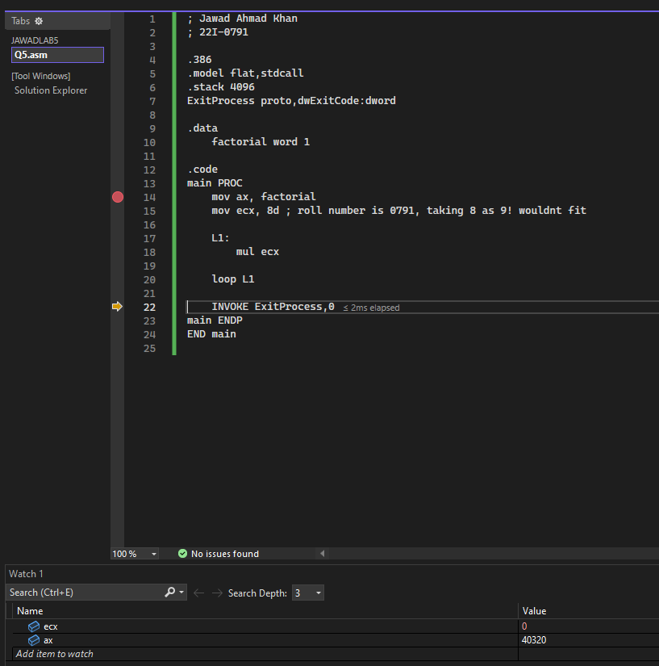**Q5**

**Q6**

